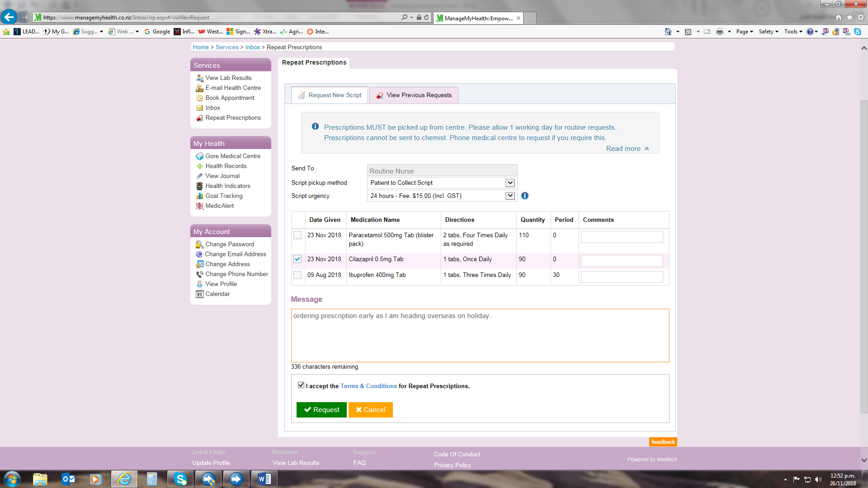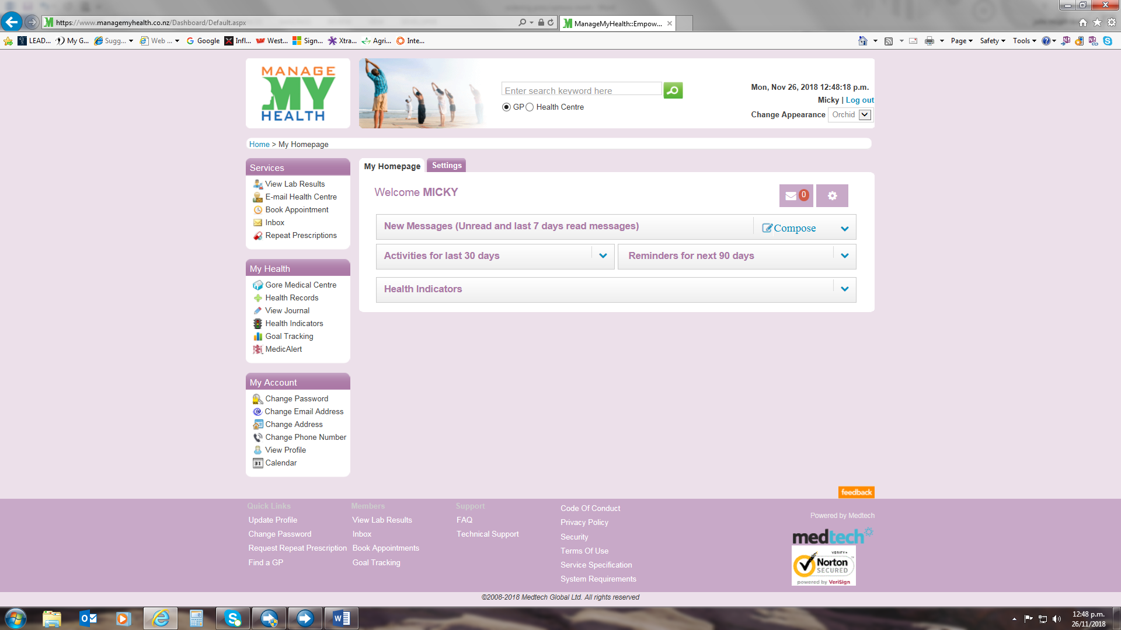

* Login to MMH
* Click on the repeat prescriptions tab
* Click on request new script
* Script pick up method: Click on the down arrow and choose patient to collect script.
* Script urgency: Click the down arrow and choose 24 hour.
* In this box there is a list of your current long term medication. Tick the box of the medication you wish to order. If the medication you require is not showing please contact the Medical centre.

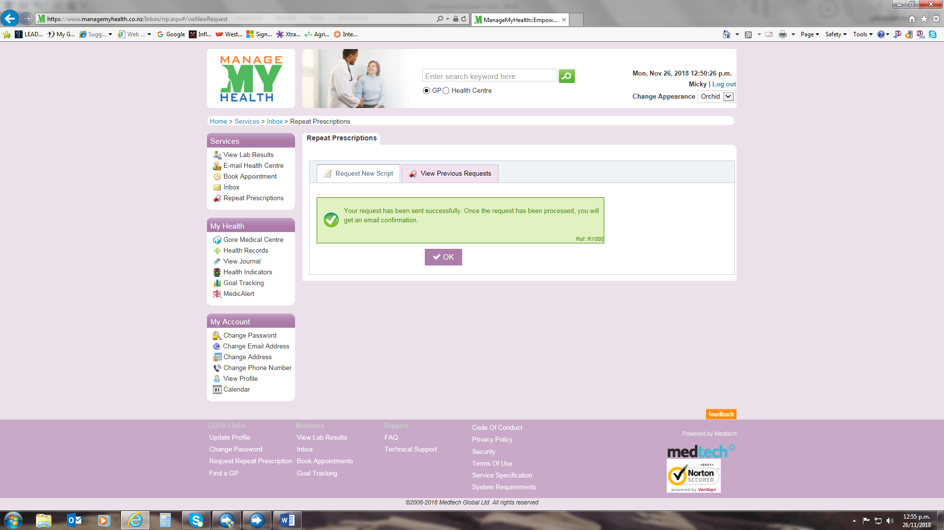

* If you wish to add a message regarding you prescription order. Type it in this box.
* Accept the terms and conditions by ticking the box.
* Click the request tab. This will send your prescription directly to the Medical centre for processing.
* You will get a message advising you that your request has been successful. Once your script has been processed you will receive an email confirmation.