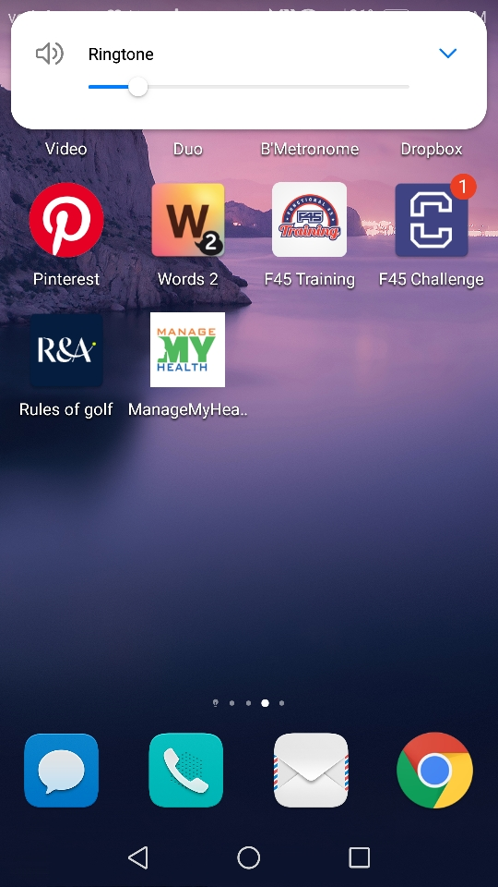

Click on the MMH icon on you device.

Login to your MMH account using your email address and your MMH password. Then click on login.

Click on the book appt tab.

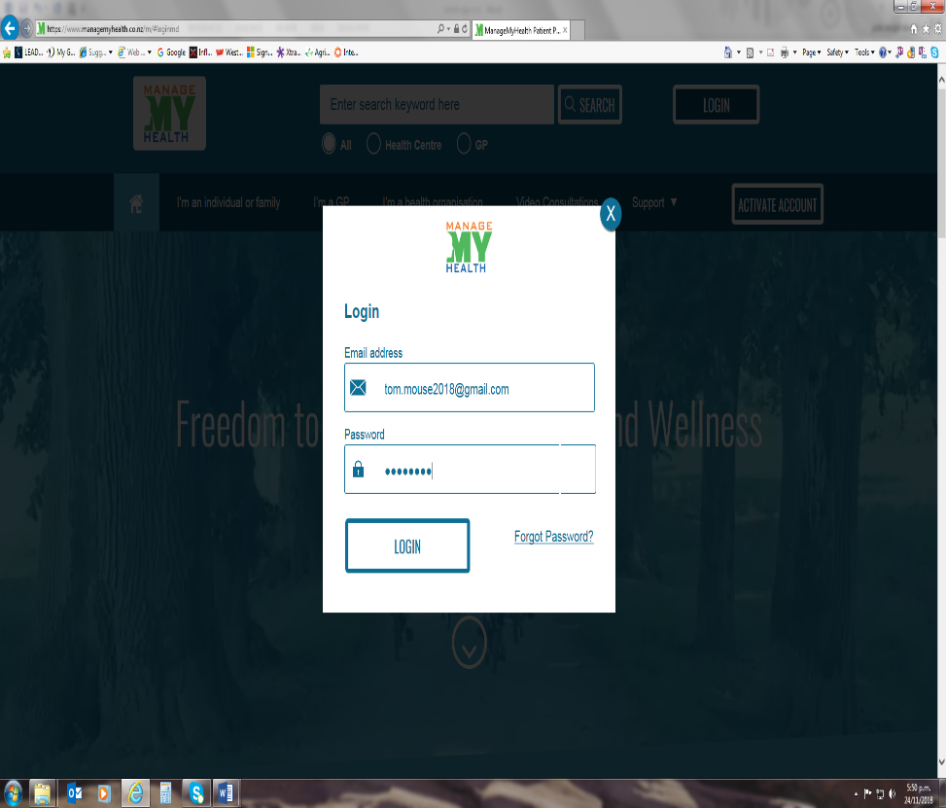

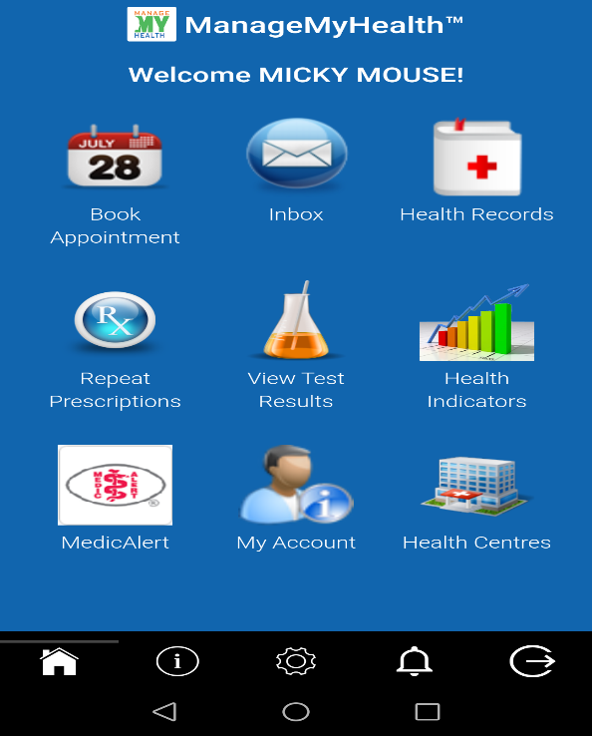

Select the provider (Doctor or Nurse Clinic) you wish to see.

Choose the date you wish to attend the appt on. To obtain the correct date , just scroll along the date line and it will move with the cursor.

Once you choose a date, all available times will show below. Click on the time that best suits (the date will be highlighted).

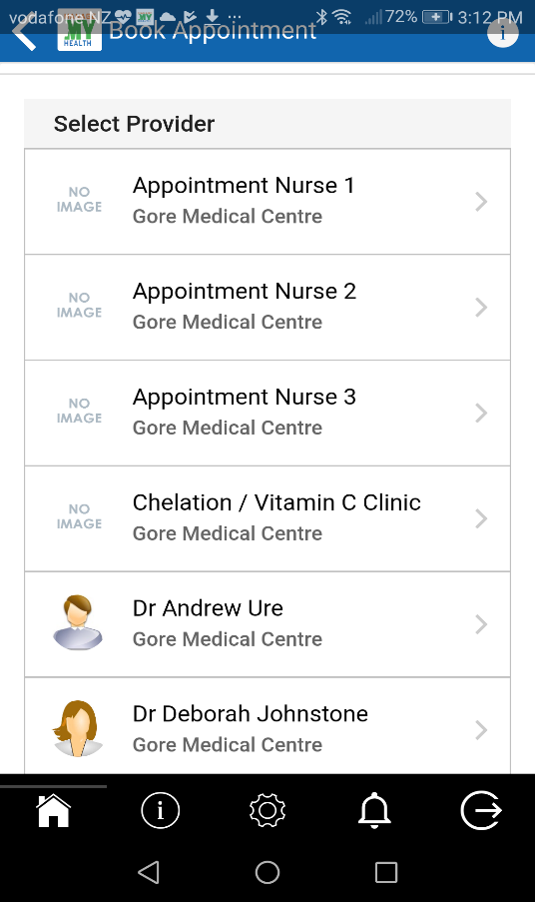

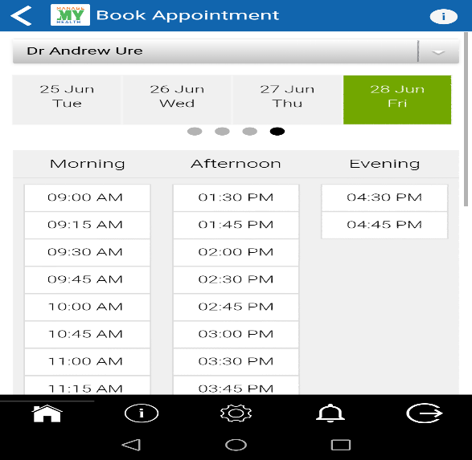

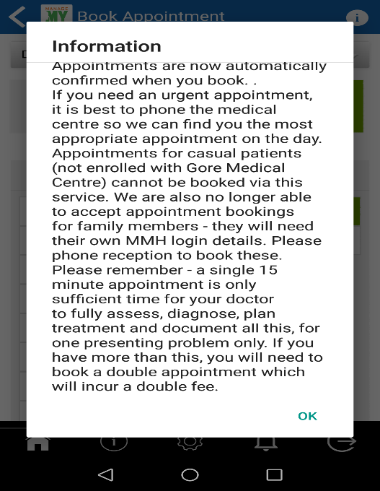

An information box will pop up next, click OK once you have read this statement.

The booking will appear stating date, time and Dr you have chosen, if you are happy with this, click on the book tab.

You will receive a confirmation email from MMH advising if the booking is accepted or declined.

