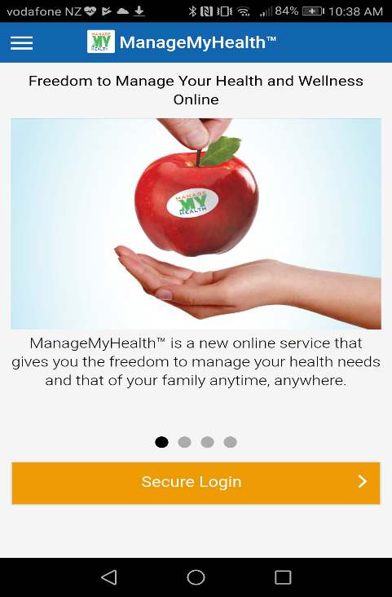

Click on the secure login tab.

Click on the activate now tab.

Enter your email address and activation code (12 digit number) which is found in your activation email sent to you from the medical centre.

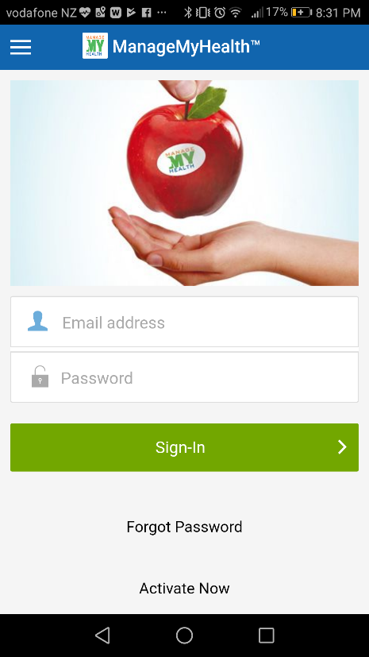

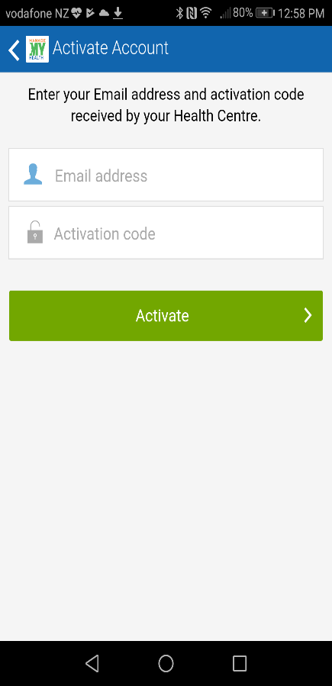

You will now receive a message in your personal email inbox from MMH. This email is to verify your email address.

Click on confirm your registration tab.

You will then receive a message from MMH to say that you have successfully completed your verification.

When you first login you will be required to set up a separate password, you will then use this password each time you use MMH.

