To create a new email address, you need to bring up google and type in Gmail sign up.

Then click on the Gmail sign up address.

Fill your details in the required boxes.

Remember to save your password and keep it somewhere safe.

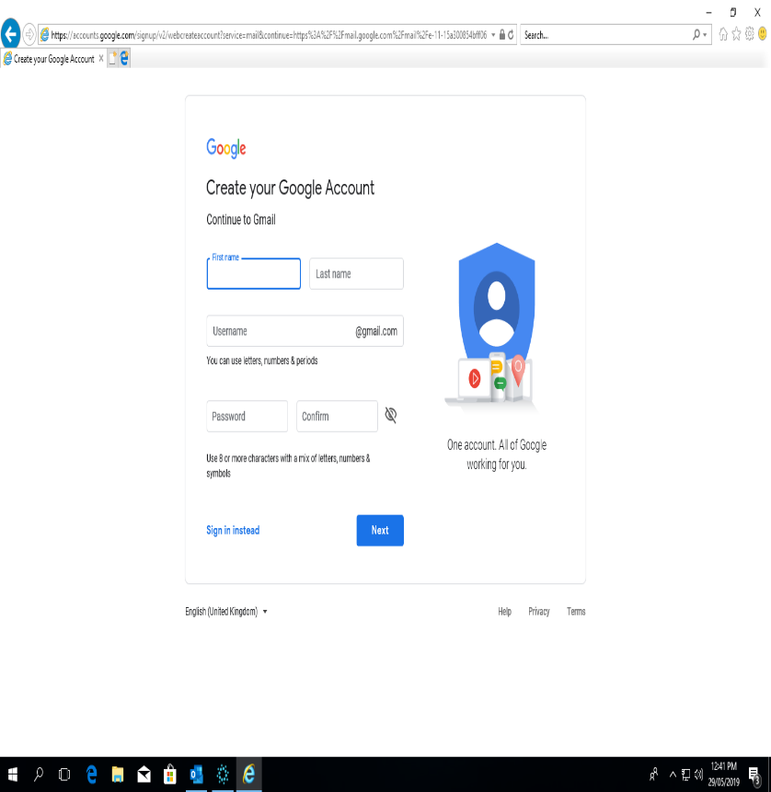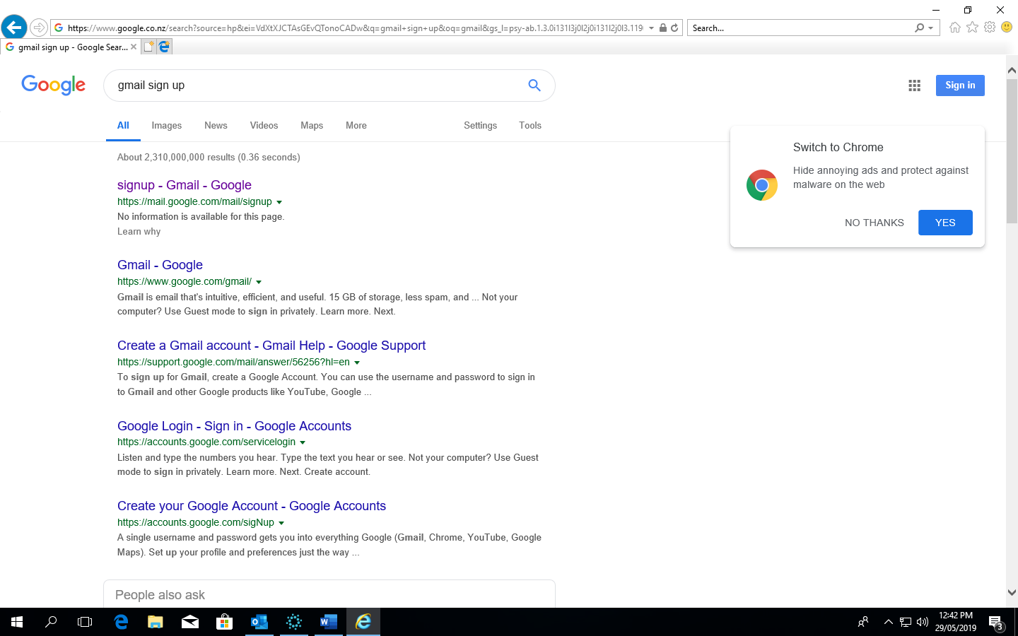

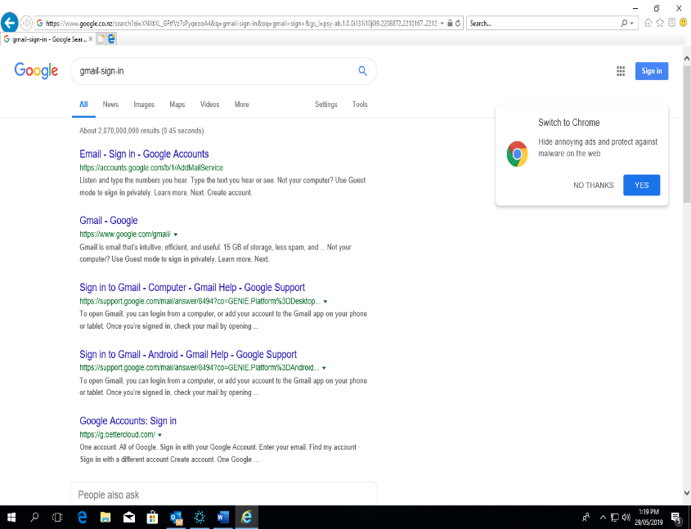

To login into your new Gmail account. Google Gmail sign-in.

Type in your email address, then click next.

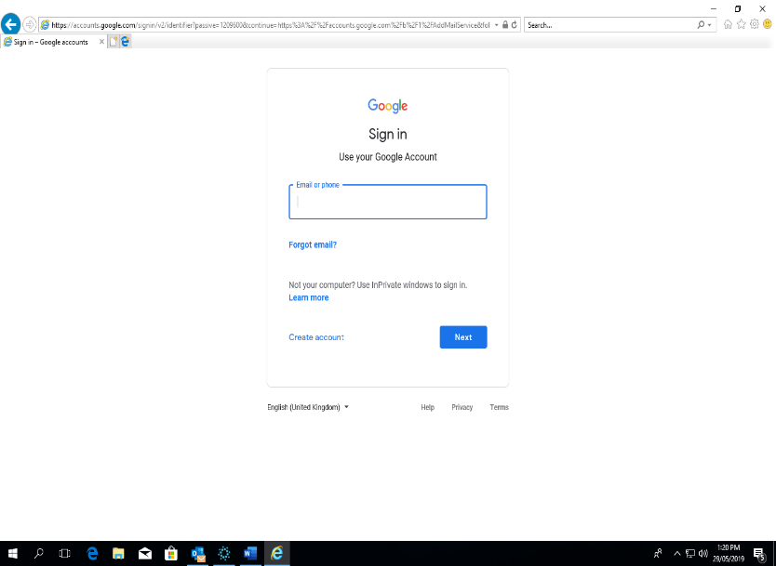

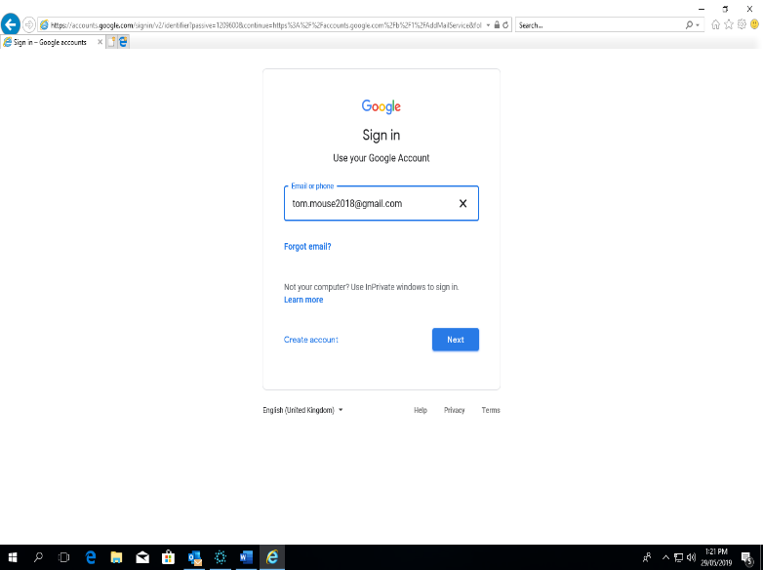

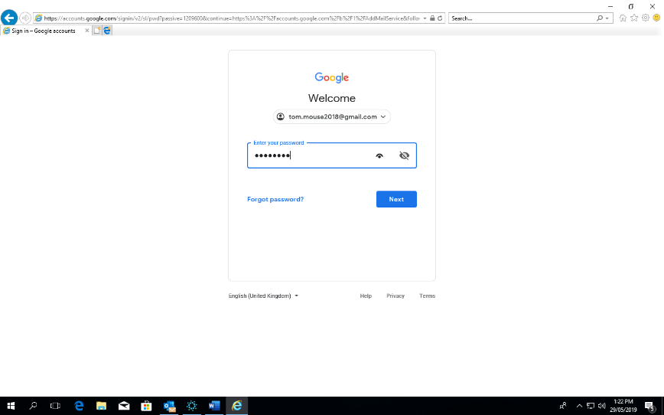

Type in your Gmail password, then click next.

This is what you email account will look like once you sign in.

If you wish to save your Gmail account to your favourites, make sure you have the Gmail account on your browser.

Click into favourites, then click on add to favourites. This will load your Gmail onto your favourites, and it saves you having to search each time for your account.

