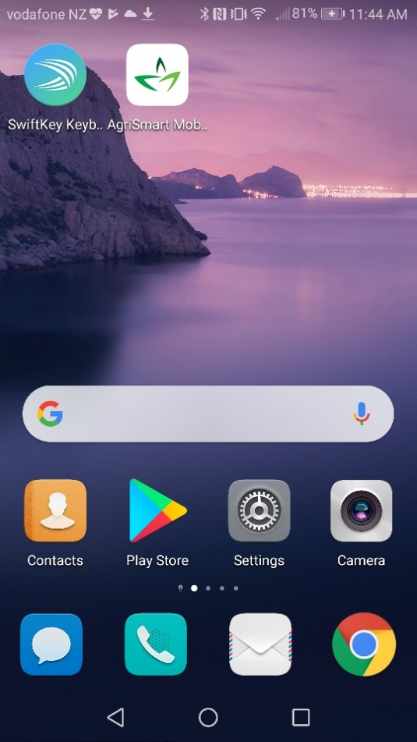

Find Play store on your cell phone or iPad settings and click on the play store icon.

Once the play store apt has opened, type in manage my health nz in the search box.

Click on the MMH icon.

Click on install.

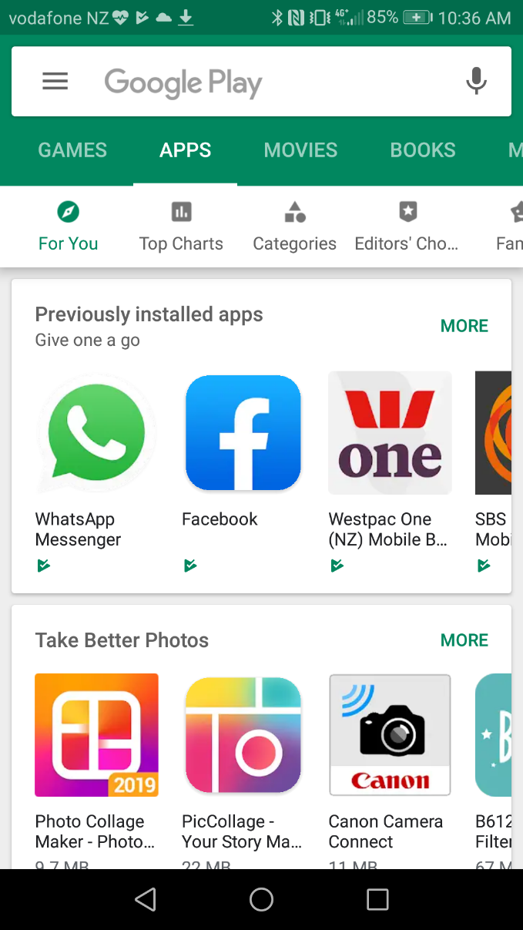

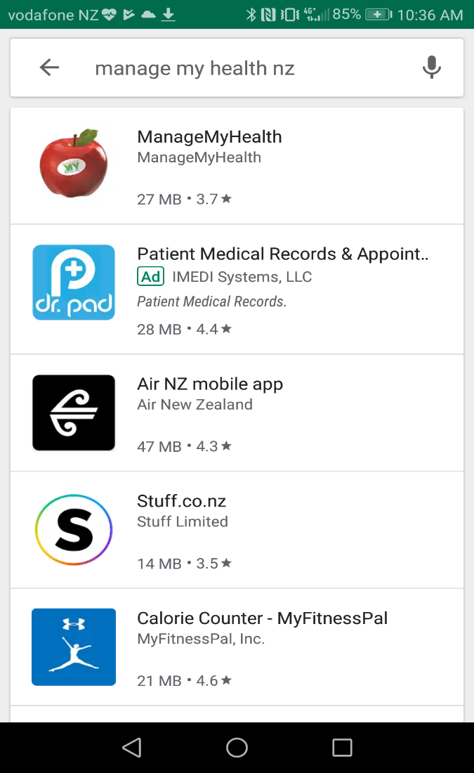

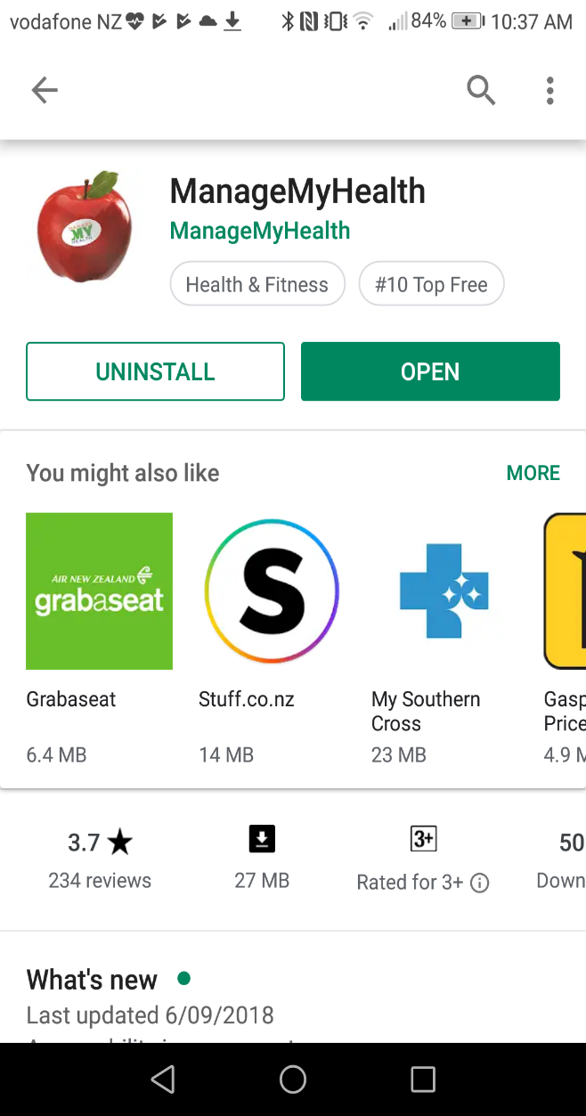

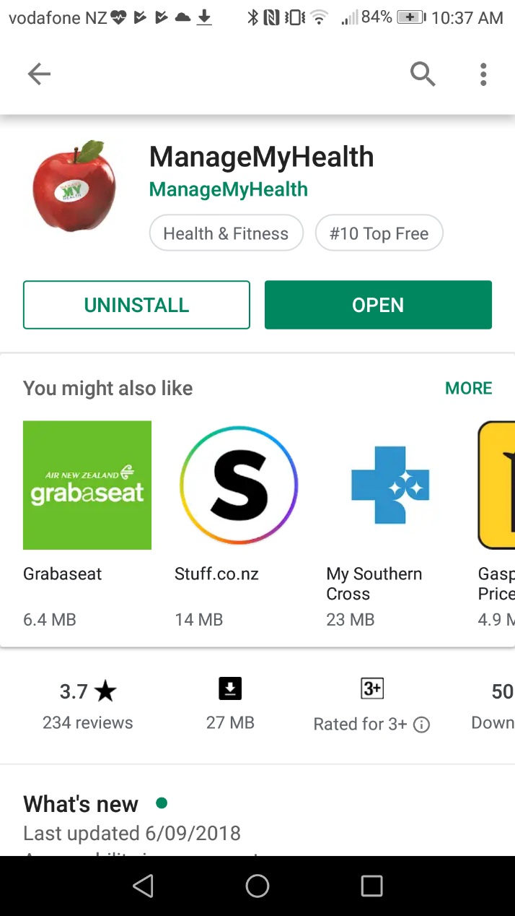

Click on open tab.

The MMH apt will now download on to your device.

Click on MMH icon to open apt.

Click on secure login to open apt

