|  |
| --- |
| * Login to MMH * Click on the repeat prescriptions tab (as the image shown below) |

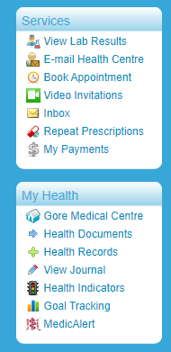

|  |
| --- |
| * Click on request new script |

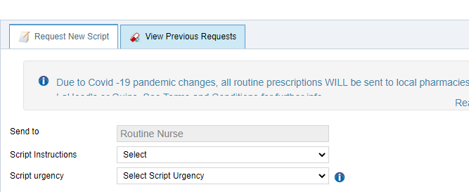

|  |
| --- |
| * **Script instructions**: Click on the down arrow and Send Script to Pharmacy * **Script urgency**: Click the down arrow and select 48 hours fee:NZ$15.00 each * **Pharmacy name:** Click the down arrow and select search pharmacy |

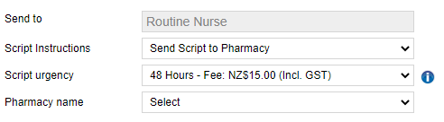

|  |
| --- |
| When you click on search pharmacy below page opens and select the options accordingly images shown below |

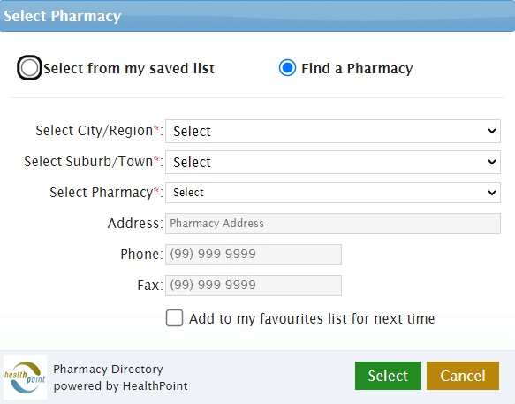

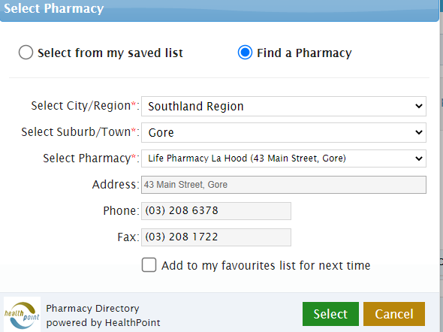

|  |
| --- |
| Please tick the box of the medication you wish to order. If the medication you require is not showing, please contact the Medical centre. |

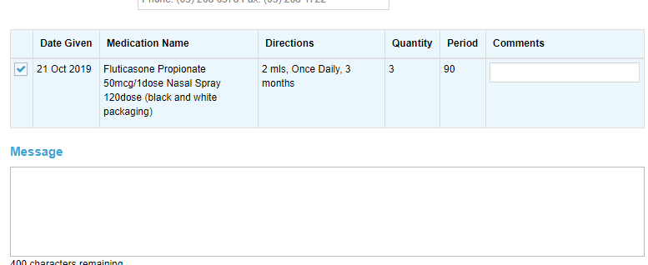

|  |
| --- |
| If you wish to add a message regarding, your prescription order. Type it in this box  Accept the terms and conditions by ticking the box.  Click the request tab. This will send your prescription directly to the Medical centre for processing. |

|  |
| --- |
| * You will get a message advising you that your request has been sent successfully. Once your script has been processed you will receive an email confirmation. |

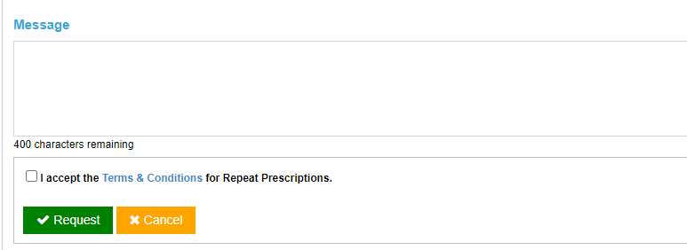

FINAL STEP