Patient Portal - Patient User Guide
Staying in Contact with your doctor just got easier – Do it Online
Login to Patient Portal  - Open your internet browser  - Search for ManageMyHealth www.managemyhealth.co.nz  Note – click on the header as shown and NOT the ‘Login’ option below  - If you are yet to register, click Activate Account Now  - Enter the email you registered with and the activation code you have be given or sent, plus the characters you see in the picture and click on Activate  - If you have an issue activating your registration please check that you have entered the email that you gave to the practice to register with.  - Also check that this email and the validation code are entered correctly.  - If your email has been entered incorrectly at the practice please contact them to update.  - Complete your Registration now screen and  Tick Terms and Conditions  Click on Complete Registration  - The Congratulations screen will display with a successful activation  - If you are an existing member, click onto Secure Login button to display the login screen.  - Click on Secure Login  - Enter your username (the email address you registered with) and the password you set up | 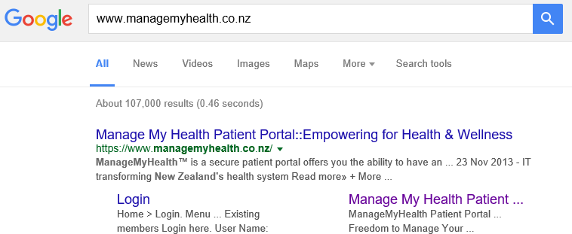  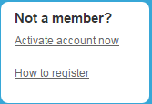  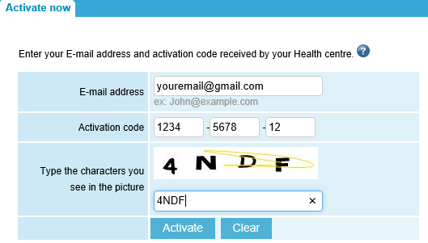  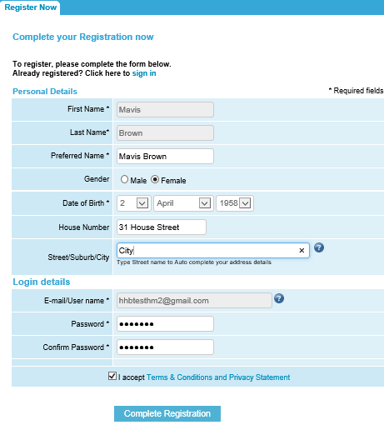  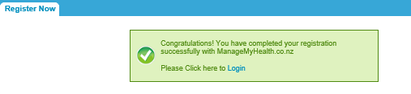  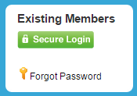  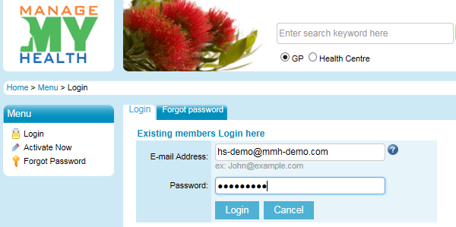
Email your doctor or the practice  - Under the Service Menu select:  E-mail Health Centre  - Select the Service Name using the drop down arrow, for example email your Doctor  - Select whom you wish to send the message to within the To field  - Type your message  - Read the terms and conditions by placing the mouse over the words. This will explain the expected time frame for a response and any associated costs.  - Tick: Accept terms & conditions  - Click: Send Message  - Your message has been sent | 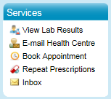  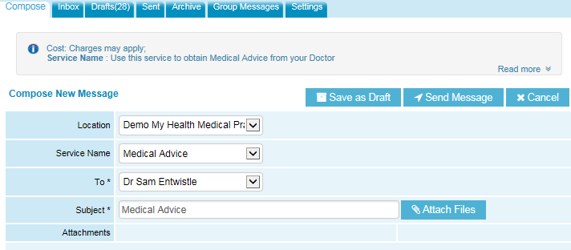  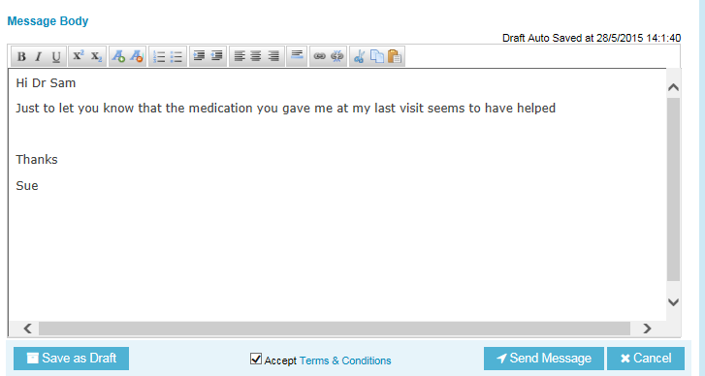  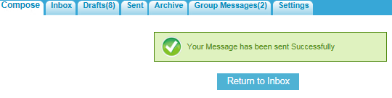
Book an appointment (this may not be an option for your practice)  This service is designed for booking standard appointments.  Available appointments from tomorrow onwards will be displayed.  - Under the Services Menu Click: Book Appointment  - Select the person you wish to see  - Select the day  - Select the time (available times are dependent on the selected date of the appointment)  - Click: Confirm the appointment request  This will display a confirmation screen.  - You must enter the reason for Appointment – however you can type private if this is appropriate  - Read the Terms and Conditions. This will explain the rules around making appointments.  - Tick: Accept terms & conditions  - Click: Confirm your booking now  - You appointment request has been sent  You will receive an email confirming your appointment.  Appointments can be cancelled online under the future appointments section. However they annot be cancelled online on the same day.  Please contact the practice to do this. | 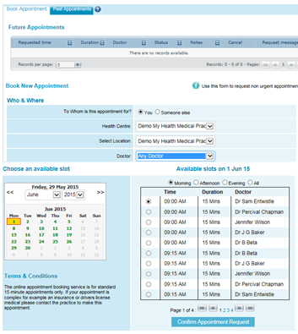  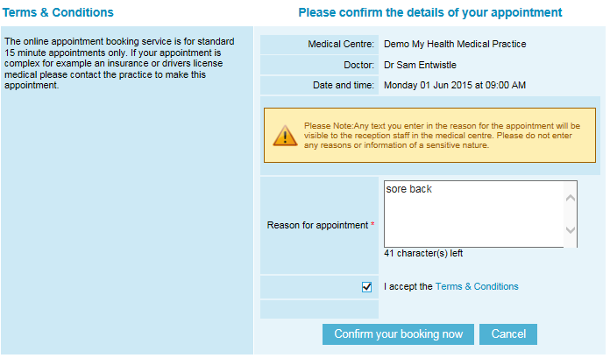  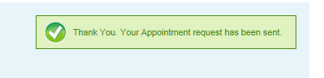
Request a repeat prescription  - Under the Service Menu select: Repeat Prescriptions  - Select your doctor from the To field ( in some practices this may be preset)  - Do not change the ‘Pickup Method’ this defaults to Patient to Collect. If you require it to be faxed you can enter the pharmacy in the message section below. (Currently if you change this option to Fax Pharmacy you will be required to enter the fax number and pharmacy details).  - Tick the regular medications your require repeated  - You must type a note in the message body box (for example fax to XYZ pharmacy or I will pick up)  - Read the terms and conditions by placing the mouse over the words. This will explain the expected time frame for your response and any potential costs.  - Tick: Accept terms & conditions  - Click: Send Message  - Your message has been sent  You will receive update messages from your doctor as to the status of your request, once they have read your request. They will display under the Activities section of your home page on the Patient Portal | 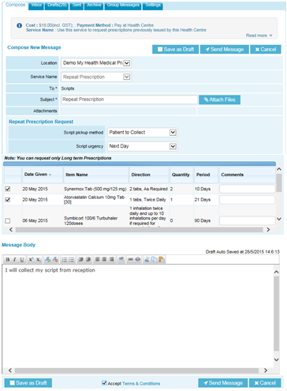  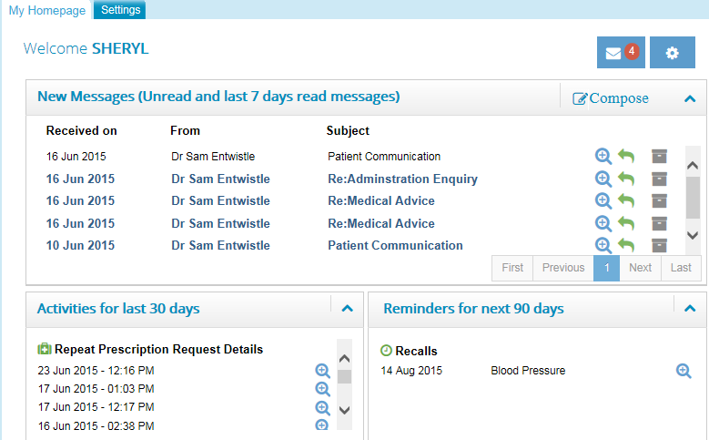
Check your messages from your practice  - Under the Services Menu Click: Inbox  - To open a received message click on the subject  - It is possible to check the read status of a message that you have sent to the practice by clicking on the Sent Tab.  - An open envelope means that the message has been read, however if the envelope is closed, your practice has not yet viewed your message | 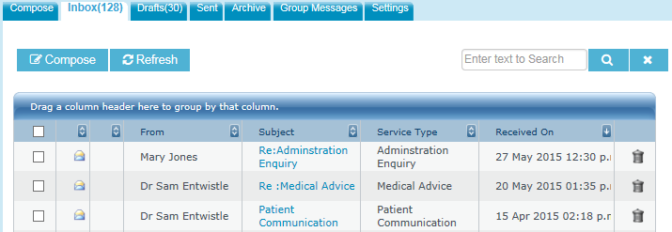  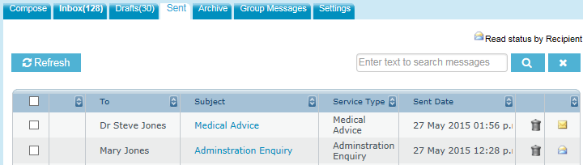
View your health summary  - Under the My Health Menu Click: Health Record  - Click on the tabs to view your health information uploaded from your practice.  Some practices may not upload your doctors notes  Your health information will update automatically, each time your doctor or nurse adds something at your practice | 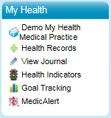  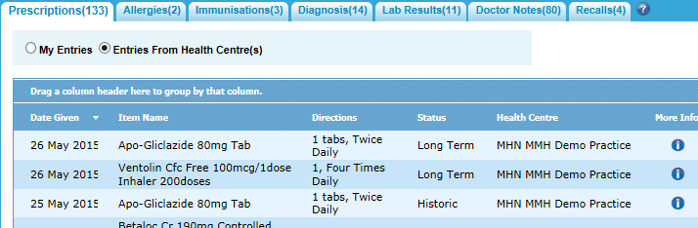

My Health Menu
- View your practices information
- View your health information
- View/use your Journal Use
- Add and graph your health measurements
- Add Goals
- Link to Medic Alert if applicable

My Account Menu  - Change your details  - View your calender  Your practice is automatically informed of any changes you make to your address and phone number | 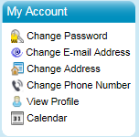
Patient Portal Help  Contact the ManageMyHealth support team if you are experiencing any technical issues with the Patient Portal  - At the lower end of the screen Click: Contact Us  - On the next screen Click: Site Help/Technical Issues  - Complete the form and Click: Send | 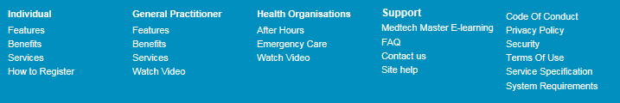  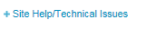
New Message Alerts

Each time a change is made to your health information at your practice, or an email has been sent you will receive a notification alert email to your email address
Charges for the Patient Portal | Your practice will advise you of any fees. They may charge you an annual fee or a fee per email. Your practice will continue to charge for repeat prescription requests. Payments for any services must be made at the practice.

